Full Office Deployment Proposal
Edward Wonder Mordey
IT 235
October 24, 2024


Full Office Deployment Proposal for Promised Land's New Data Centre in Independence, Missouri

Site Information
Occupy 15,000 square feet
50 employees
Hybrid call centre
Site Address
Promised Land Data Centre
18801 East 39th St S
Independence, MO 64057
Overview
Promised Land is excited to unveil its latest venture—a new, 15,000-square-foot data centre in Independence, Missouri. This state-of-the-art facility will house a team of 50 dedicated professionals and will serve as our secondary IT hub, supporting hybrid call centres across the United States and Canada. This deployment proposal outlines a scalable and secure IT infrastructure designed to meet our current needs and facilitate future growth. By establishing this strategically located data centre, we aim to significantly enhance our operational capacity, ensuring seamless and efficient service delivery for our call centres nationwide.
Managing Roles and Features

I recommend utilizing Windows Server 2022 Datacentre edition, incorporating:

1. Active Directory Domain Services for centralized user management
2. DNS Server role for efficient name resolution
3. DHCP for dynamic IP address allocation
4. Hyper-V for virtualization
5. Storage Spaces Direct for scalable storage

Purpose: Centralized management and improved security.

Reasoning: Windows Server 2022 Datacentre edition provides a robust platform.

Challenges:

- Complexity in configuring Active Directory Domain Services.
- Ensuring compatibility.

Solutions:

- Conduct planning and testing.
- Collaborate with IT staff.

Benefits:

- Centralized management
- Improved security
- Enhanced scalability
- Efficient resource utilization

Implementation Plan:

- Install Windows Server 2022 Datacentre
- Configure Active Directory Domain Services
- Set up DNS Server role
- Configure DHCP
- Deploy Hyper-V

Cloud Concepts + Virtualization

I recommend integrating Microsoft Azure, providing:

1. IaaS for scalable infrastructure
2. PaaS for efficient application deployment
3. Hybrid Backup and Recovery for data protection

Purpose: Scalable infrastructure and efficient application deployment.

Reasoning: Microsoft Azure integration provides flexibility.

Challenges:

- Managing hybrid cloud environments.
- Ensuring data security.

Solutions:

- Implement robust security.
- Conduct audits.

Benefits:

- Scalability
- Flexibility
- Cost-effectiveness
- Enhanced disaster recovery

Implementation Plan:

- Set up Azure subscription
- Configure IaaS and PaaS
- Implement Hybrid Backup and Recovery

Managing IP Addressing

I propose using:

1. DHCP for dynamic IP address allocation
2. IPv4/IPv6 addressing for compatibility
3. DNS for name resolution
4. IPAM for centralized IP address management

Purpose: Efficient IP address management.

Reasoning: DHCP, IPv4/IPv6, DNS, and IPAM streamline IP allocation.

Challenges:

- Managing IP address conflicts.
- Ensuring scalability.

Solutions:

- Implement IPAM.
- Conduct network audits.

Benefits:

- Efficient IP address management
- Improved network performance
- Simplified troubleshooting

Implementation Plan:

- Configure DHCP
- Set up IPv4/IPv6 addressing
- Implement DNS
- Configure IPAM

Files + Directories

I recommend implementing:

1. NTFS permissions for secure file access
2. Access control lists for granular permissions
3. File and Storage Services for efficient file management

Purpose: Secure file access and management.

Reasoning: NTFS permissions, access control lists, and File and Storage Services ensure secure file management.

Challenges:

- Managing complex file permissions.
- Ensuring data integrity.

Solutions:

- Implement granular permissions.
- Conduct regular backups.

Benefits:

- Secure file access
- Efficient file management
- Simplified permissions management

Implementation Plan:

- Configure NTFS permissions
- Set up access control lists
- Implement File and Storage Services

Hardware + Software Installation

I propose:

1. Intel Xeon processors for high-performance hardware
2. 16 GB RAM for efficient memory management
3. 1 TB storage for robust data storage

Purpose: High-performance hardware and efficient software installation.

Reasoning: Intel Xeon processors, 16 GB RAM, and 1 TB storage provide robust hardware.

Challenges:

- Ensuring hardware compatibility.
- Managing software updates.

Solutions:

- Conduct hardware testing.
- Implement automated software updates.

Benefits:

- High-performance hardware
- Efficient software installation
- Enhanced security

Implementation Plan:

- Procure server hardware
- Install Windows Server 2022 Datacentre
- Configure antivirus solutions
- Set up monitoring tools

DNS Implementation + Management

I recommend:

1. DNS Server role for efficient name resolution
2. Forward and reverse lookup zones for secure DNS management
3. DNSSEC for security
4. DNS forwarding for simplified DNS management

Purpose: Efficient name resolution and security.

Reasoning: DNS Server role, forward and reverse lookup zones, DNSSEC, and DNS forwarding ensure secure DNS management.

Challenges:

- Managing DNS zone files.
- Ensuring DNS security.

Solutions:

- Implement DNSSEC.
- Conduct regular DNS audits.

Benefits:

- Efficient name resolution
- Improved security
- Simplified DNS management

Implementation Plan:

- Configure DNS Server role
- Set up forward and reverse lookup zones
- Implement DNSSEC
- Configure DNS forwarding

Users & Groups + Management
I propose using Active Directory Domain Services, providing:

1. Centralized user management
2. Group Policy Objects for security and compliance
3. Organizational units for structured management

Purpose: Centralized user management.

Reasoning: Active Directory Domain Services provides robust user management.

Challenges:

- Managing complex user permissions.
- Ensuring compliance.

Solutions:

- Implement Group Policy Objects.
- Conduct regular user audits.

Benefits:

- Centralized management
- Improved security
- Efficient user management

Implementation Plan:

- Configure Active Directory Domain Services
- Create Group Policy Objects
- Set up organizational units
- Assign user roles and permissions
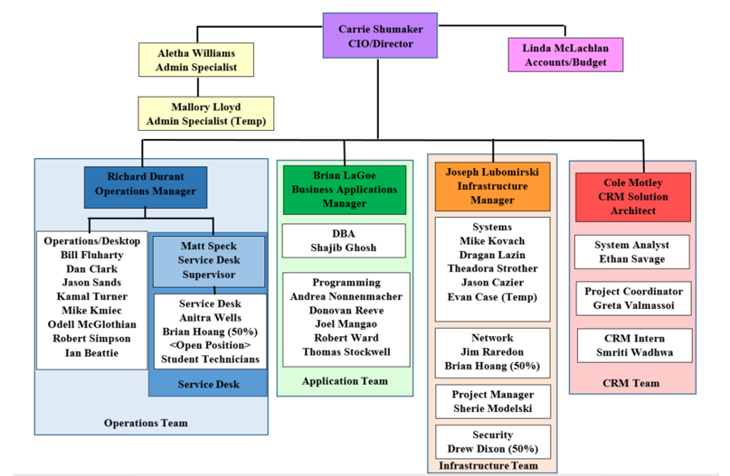

Active Directory + Group Policy Objects

I recommend implementing:

1. Password policies for secure authentication
2. Account lockout policies for security
3. Kerberos authentication for secure login

Purpose: Improved security and policy management.

Reasoning: Group Policy Objects ensure streamlined policy management.

Challenges:

- Managing complex policy settings.
- Ensuring compliance.

Solutions:

- Implement password policies.
- Conduct regular policy audits.

Benefits:

- Improved security
- Efficient policy management
- Simplified compliance

Implementation Plan:

- Create Group Policy Objects
- Configure password policies
- Set up account lockout policies
- Implement Kerberos authentication

Managing Servers in a Hybrid Model

I propose using:

1. System Centre Operations Manager for centralized monitoring
2. Azure Monitor for cloud monitoring
3. Automated tasks for efficiency

Purpose: Centralized monitoring and disaster recovery.

Reasoning: System Centre Operations Manager provides robust monitoring.

Challenges:

- Managing hybrid cloud environments.
- Ensuring data security.

Solutions:

- Implement robust security.
- Conduct regular backups.

Benefits:

- Centralized management
- Improved monitoring
- Enhanced disaster recovery

Implementation Plan:

- Install System Centre Operations Manager
- Configure centralized monitoring
- Set up automated tasks
- Integrate Azure Monitor

Managing Storage Services + File Services

I recommend implementing:

1. Storage Spaces Direct for scalable storage
2. Data deduplication for efficient storage
3. File and Storage Services for efficient file management

Purpose: Scalable storage and efficient data management.

Reasoning: Storage Spaces Direct provides scalable storage.

Challenges:

- Managing storage capacity.
- Ensuring data integrity.

Solutions:

- Implement data deduplication.
- Conduct regular storage audits.

Benefits:

- Scalable storage
- Efficient data management
- Improved performance

Implementation Plan:

- Configure Storage Spaces Direct
- Set up data deduplication
- Implement File and Storage Services
- Monitor storage capacity

Disaster Recovery

I propose implementing:

1. Azure Backup for cloud-based backup
2. System Centre Data Protection Manager for on-premises backup
3. Disaster recovery plan for business continuity

Purpose: Ensuring business continuity.

Reasoning: Azure Backup and System Centre Data Protection Manager provide robust backup and recovery.

Challenges:

- Ensuring data integrity.
- Managing backup and recovery processes.

Solutions:

- Implement automated backups.
- Conduct regular disaster recovery drills.

Benefits:

- Improved data protection
- Efficient disaster recovery
- Business continuity

Implementation Plan:

- Configure Azure Backup
- Install System Centre Data Protection Manager
- Create disaster recovery plan
- Conduct regular drills

Security + Compliance

I recommend implementing:

1. Windows Defender Advanced Threat Protection for endpoint security
2. Azure Security Centre for cloud security
3. Compliance policies for regulatory adherence

Purpose: Ensuring security and compliance.

Reasoning: Windows Defender Advanced Threat Protection and Azure Security Centre provide robust security.

Challenges:

- Managing complex security settings.
- Ensuring compliance.

Solutions:

- Implement security policies.
- Conduct regular security audits.

Benefits:

- Improved security
- Efficient compliance management
- Simplified risk management

Implementation Plan:

- Configure Windows Defender Advanced Threat Protection
- Set up Azure Security Centre
- Create compliance policies
- Conduct regular security audits

Conclusion

This deployment proposal ensures Promised Land's new data centre meets current and future needs, providing a robust, scalable, and secure IT infrastructure.

Assumptions and More Reasoning

Assumptions:

1. Existing Azure subscription and infrastructure
2. IT staff has basic knowledge of Windows Server and Azure

Reasoning:

This proposal balances scalability, security, and manageability, ensuring Promised Land's data centre meets current and future needs, supports business growth, and provides:

1. Enhanced reliability and uptime for critical systems
2. Improved data protection and compliance
3. Increased efficiency and productivity for IT staff
4. Better resource utilization and cost optimization
5. Scalable infrastructure for future expansion and innovation

By implementing this proposal, Promised Land can:

1. Ensure business continuity and minimize downtime
2. Protect sensitive data and maintain regulatory compliance
3. Improve IT service delivery and responsiveness
4. Optimize resource utilization and reduce costs
5. Position itself for future growth and innovation

This proposal aligns with Promised Land's strategic objectives, providing a robust, scalable, and secure IT infrastructure that supports business success.

